Name: Fatima Naeem
Roll no: 127
Subject: AI (lab)
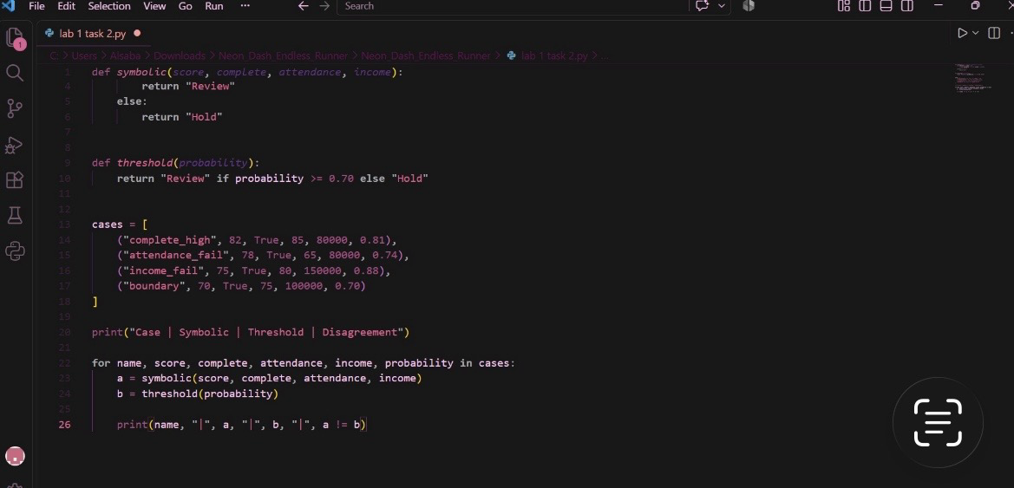
Task 1

